Gantt Chart Planning

The first thing we needed to do in order to structure the project and manage our time efficiently was create a Gannt Chart using Excel. In doing so we would be able to estimate the time required in order for us to complete each of these tasks. The tasks set before us included listing functional and non-functional requirements, risk assessment, creating a use case diagram, making and UML Class diagram, compiling work from the planning stages into a single PDF document, developing our program and debugging the program. **INCLUDED STUFF FOR THE ACTUAL PROGRAM DEVELOPMENT HERE BUT HAVEN’T ADDED IT TO THE GANNT CHART. NOT SURE IF I SHOULD OR NOT YET.** Also included in the Gantt Chart were milestones. In this case, these were our submission deadlines.

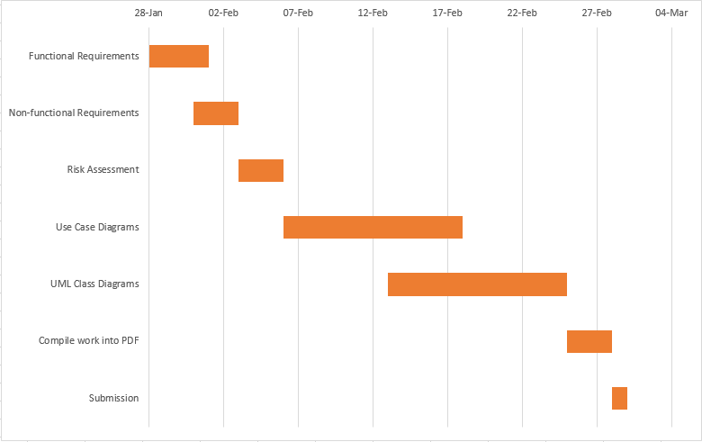

Risk Assessment

One of the stages of planning was to conduct as risk assessment to identify all the possible dangers involved with our project, and determine ways in which these potential dangers could be prevented or minimised. Although the risks involved with our project, and the field of computer science in general are far and few in between, there are a few risks that can present a significant threat. For instance, RSI or chronic back pains. Threats such as these can be easily avoided if people sit correctly and comfortably, and ensure that they type with neutral hand positions. Although much more extreme and unlikely to occur in university labs, things like electrocution also had to be taken into account while conducting the assessment.

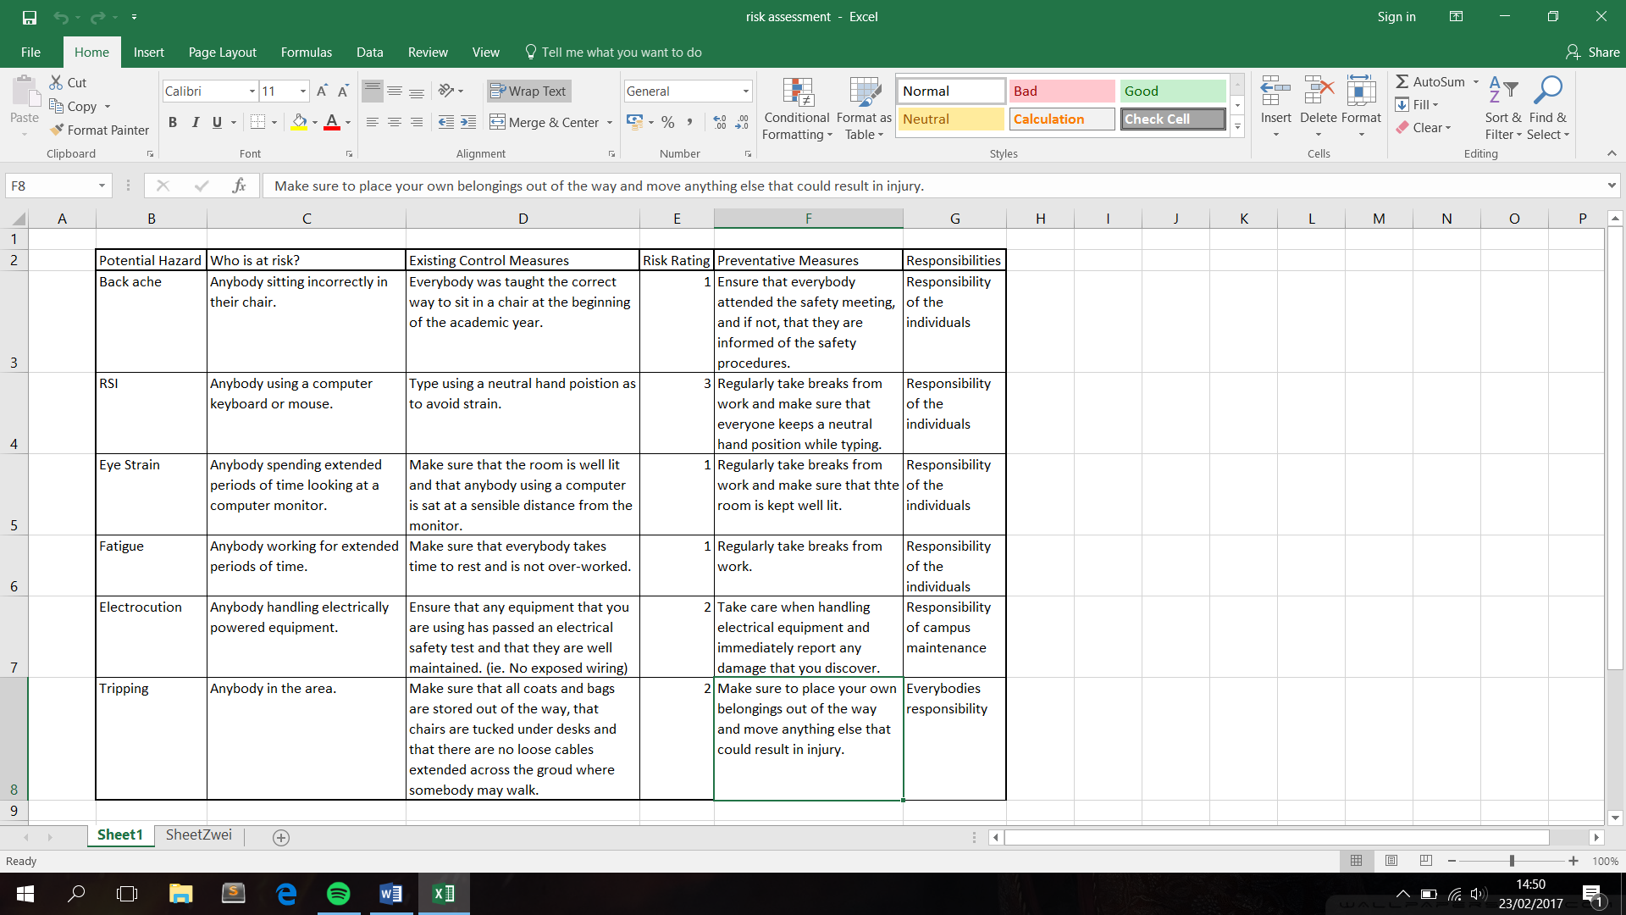

In order to rank all of the identified risks more clearly, we created a colour coded table that showed all of the risks and ranked them by severity and likelihood. In doing so, we were able to easily recognise which risks required us to take action. These were the risks that appeared closer to the top left of the table. Those nearer to the bottom right of the table were insignificant or trivial by comparison.

